|  |  |  |
| --- | --- | --- |
| **Original Paper** | **Her Project** | **Our Project** |
| The original paper applied neural networks to fine needle aspirations to determine a diagnosis. Moreover the paper employed neural networks on the diagnosis of numerical and FNA-slide data. | Her project applied neural networks to numerical fine needle aspiration data to determine a diagnosis | Our project applied neural networks to fine needle aspirations and mammographic data. |
| The original paper employed data from the Wohlberg Wisconsin Breast Cancer dataset. | Her project employed the same dataset as seen in the original paper. | Our project employed not only the Wisconsin dataset from the original paper, but also the MIAS dataset for mammographic images. |
| The original paper made use of error backpropagation, an extremely common algorithm for training neural networks. | Her project also used error back propagation for training neural networks. | Our project was developed on the scope of a new algorithm that we created during the course of the project. Our algorithm, the accelerative learning algorithm, is a heavily modified version of the algorithm used in the original paper. |
| The original paper employed a neural network with four layers consisting of one neuron for every case in the training dataset, around 600. | The neural network structure within her project had three layers and a pre-processing layer. The layers were structured {I, 6, 1) where I consists of all of the inputs connected to a preprocessing layer. | Our project used a network structure paradigm seen in the original paper, which structured neural networks based on the amount of datapoints within the dataset. The structure more specifically creates a proportionality between the number of weights and the number of training examples. Our structure consisted of 4 layers given by {9, 16, 6, 1}. |
| The original paper used 10-fold cross-validation and conclusiveness for neural networks. | The Wenger project employed the same 10-fold cross-validation conclusiveness test as the original paper | Our project used a 10-fold cross-validation test following the original paper. |
| The original paper used malignancy weighting | Her paper employed malignancy weighting. | We employed malignancy weighting according to the original paper. |
| The original paper applied neural networks to the FNA datasets and showed that convergence is possible. | Her project employed ideas similar to the original paper but differed by showing that as more data are added to a neural network during training, diagnosis becomes more accurate. | Employing our own modified version of error backpropagation, accelerative learning rate, we showed how three different algorithms affected convergence by iteration and also how accelerative learning rate and momentum affect the error output of the neural network on a given problem set, namely breast cancer. |

**Comparison of Programming**

Brittany Wenger’s abstraction structure and development paradigm is completely different from our project. You can see her **Java** UML diagram below:

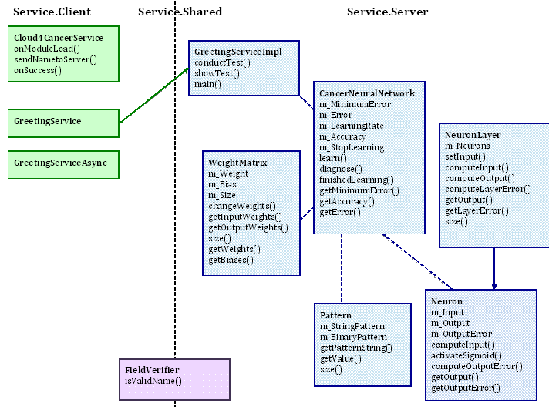

In a complete, unique, and absolute contrast, the **C#** UML Diagram of our project is given below. It is quite clear that the implementation, in our case, is different from the Wenger implementation. 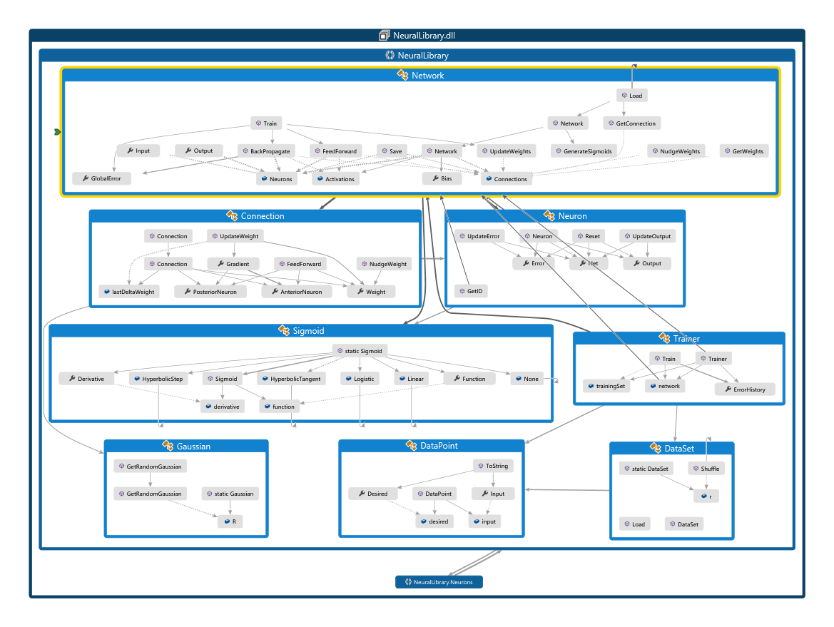

**Network Comparison**

There are clear and distinct differences in the network structure of both projects. As aforementioned, both projects employ a type of network diagram figure portrayed in the original paper. Upon a cross comparison examination, there are many differences in structure and in origin.

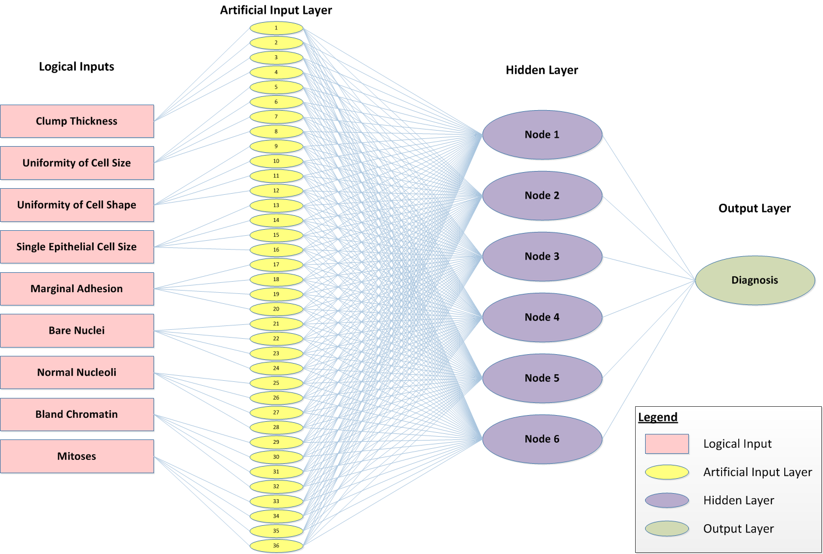Wenger

Guss-Chen

